IT 3203 Web Development Project

Center For   
applied research in Information Technology report (part II)

Denise Mutombo

The “Careers” page gives a few information to invite students to apply for some available position. The first part of the page is the same banner that shows on all other pages of the website. The second part presents the available positions. The last part is a form that develops as the user makes choices in order to determine if the user could qualify for the position.

1. Design a form for students to enter their information and get the evaluation results.

The first script makes sure that any of the forms that will be created after the first one will not show when loading the page because they will be shown appropriately as selections are made.

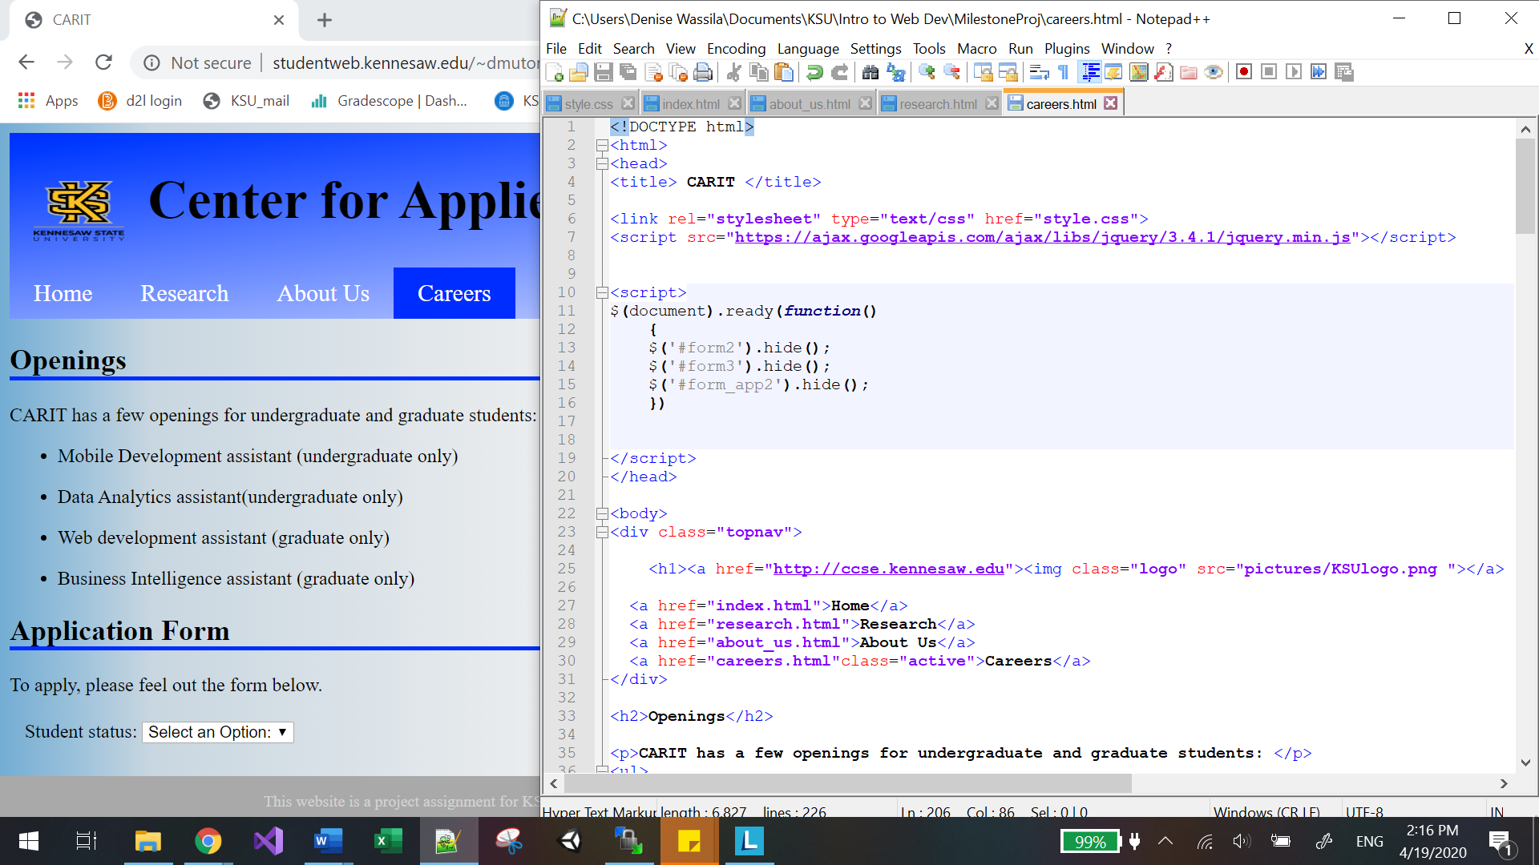

1. The student should first select his student status.

The first form is a basic form to allow the student to choose his status which can be either undergraduate or graduate. The restrictions are maintained by allowing only one of the two to be selected.

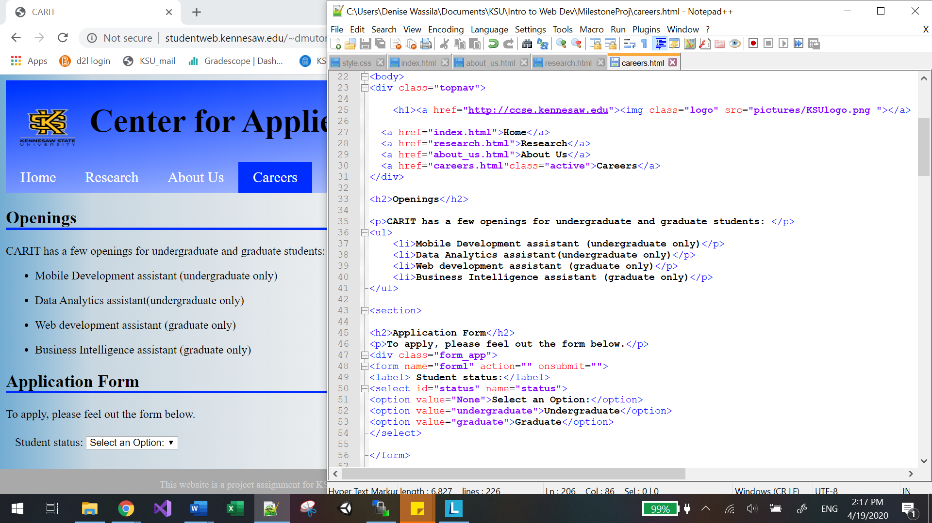

If a choice is made and is changed for the default option “Select an option”, a pop up appears asking for a choice to be made.

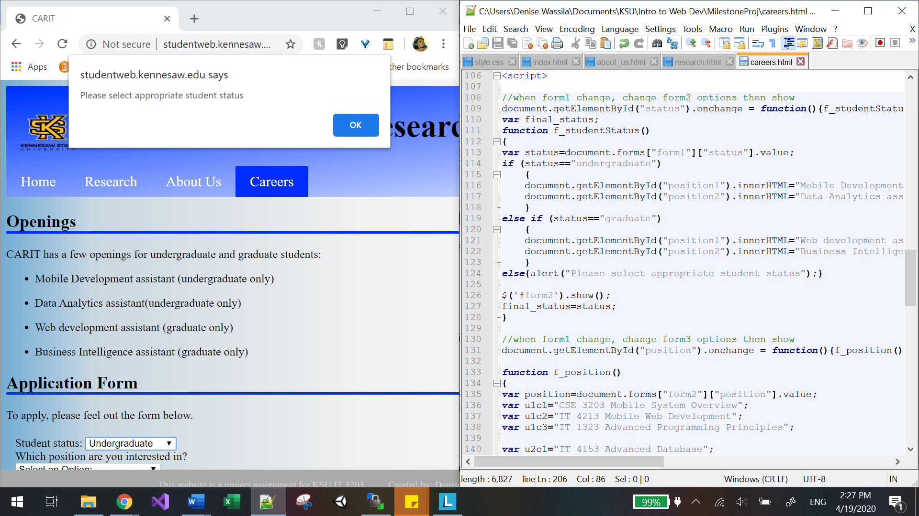

1. Depending on the information provided, different set of course titles should be presented.

When the students select his status as undergraduate the second form shows the options: Mobile Development assistant and Data Analytics assistant, which are the position offered to undergraduates as stated in the introduction of the page.

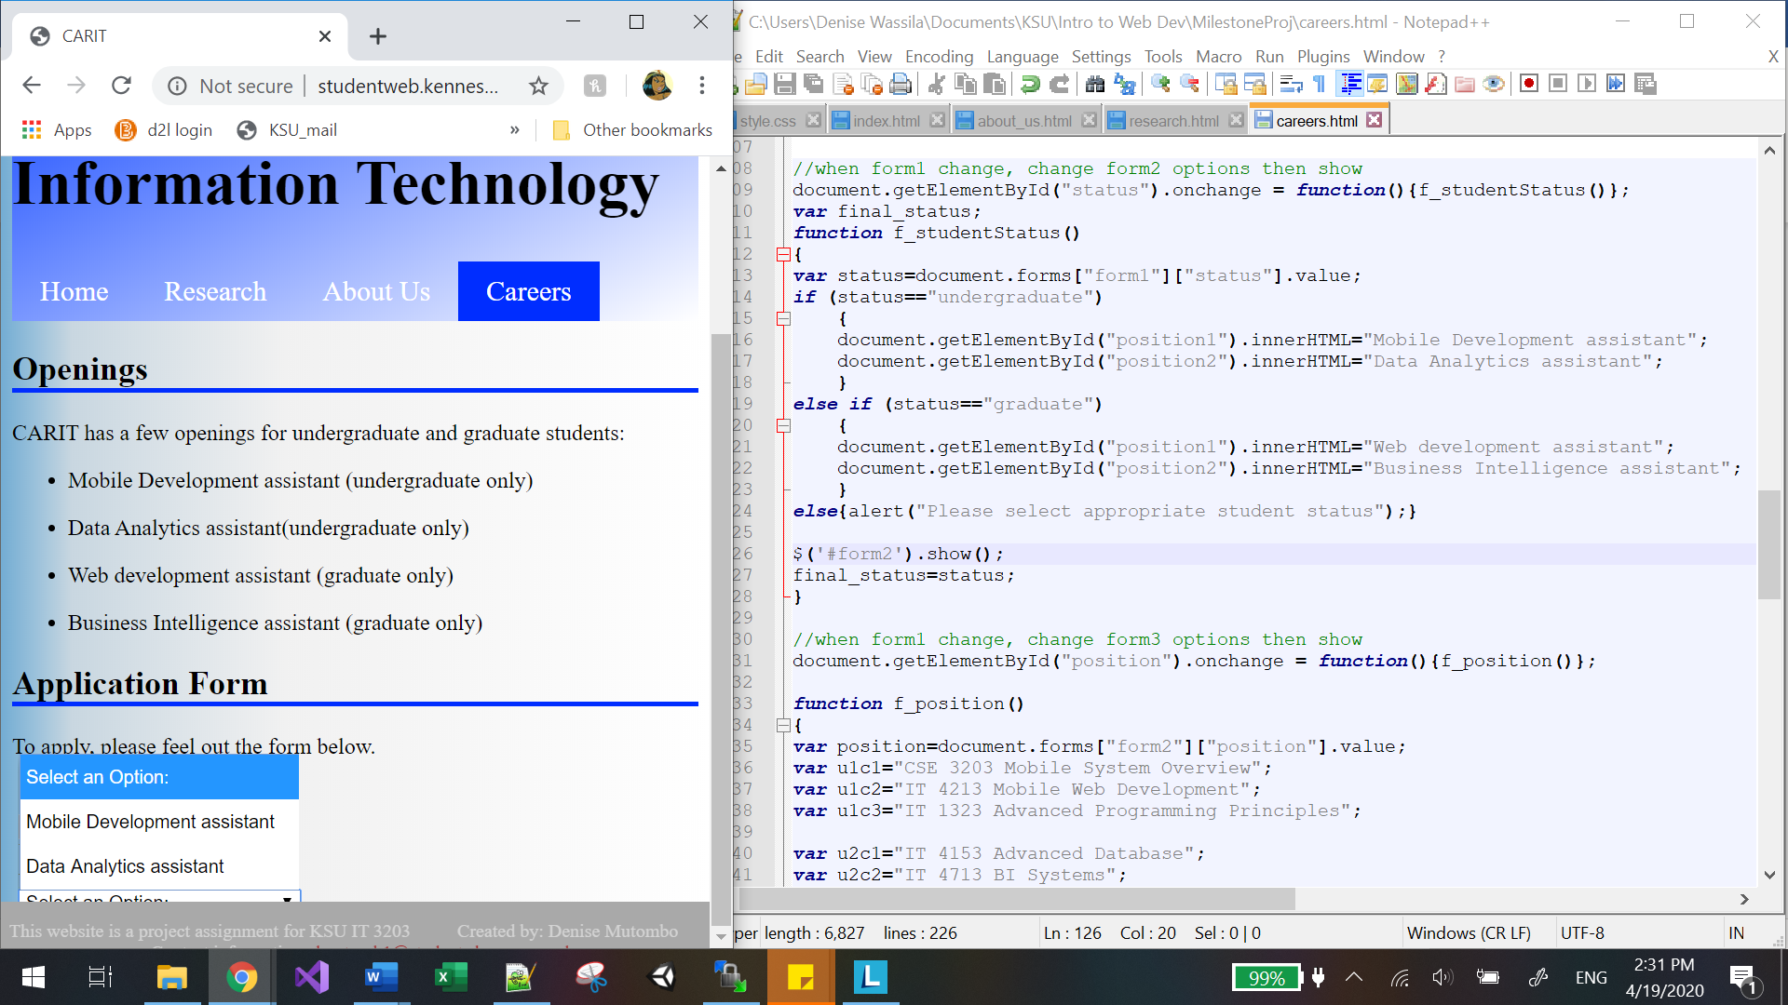

If the selection made for the first form is “graduate” then the selections offered for the second form are changed appropriately to “Web development assistant” and “Business Intelligence assistant”. The changes to the second form will also happen if changes to the status happen at this point.

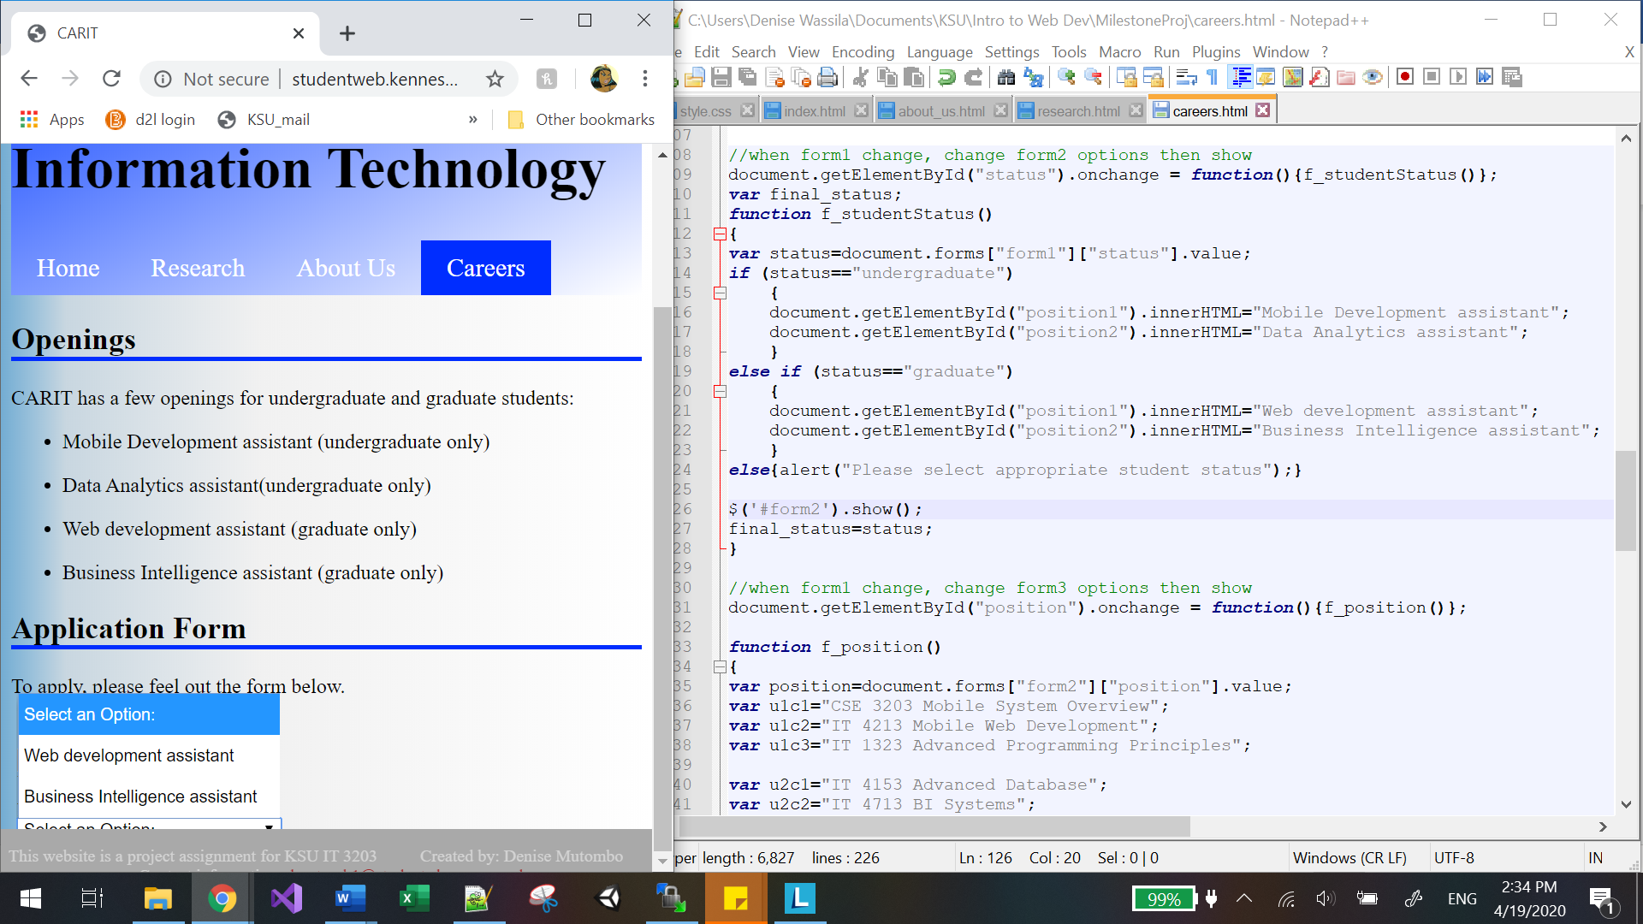

1. A student then should enter or select a letter grade (A, B, C, D, or F) for each course. Use appropriate form controls to accept user inputs.

Once the selection is made for a position, the third form appears asking for the student to choose the grades he/she received in each of the classes appropriately displayed depending on the previous selection, the position. Then the student is expected to click the evaluate button to continue with the process. The script allows the change of courses based on the position and status of the student but also takes into account the change that can be made if the student goes for a different position at this stage of the process, meaning that the courses will changes right away if the student changes the selection of position.

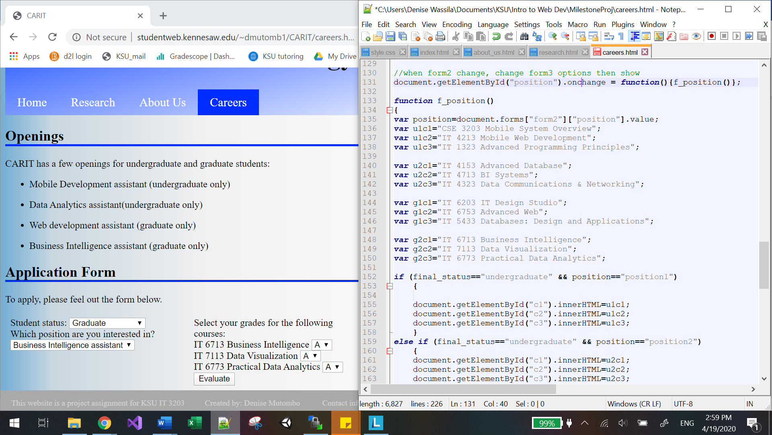

1. After hitting the “Evaluate” button, the result (average grade) with a message should be displayed. If the average grade requirement is met, display a congratulation message with instructions to apply.

The script allows for the congratulatory message to show when the GPA of the courses is greater than the minimum allowed for each position.

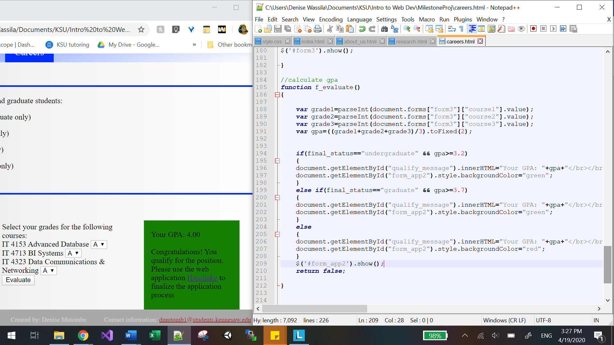

If the average grade requirement is not met, thank his/her interest (make up your own text) but do not show the application form link.  
The script allows for the other message to show when the GPA of the courses is lower than the minimum allowed for each position.

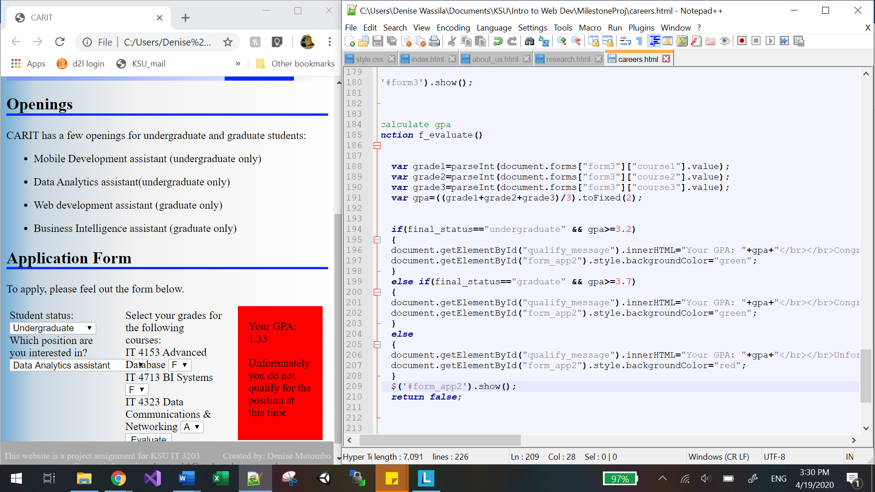

1. Styling

In terms of styling, the form is following a pattern from left to right by showing the next process of the form that way until the qualification message appears, which itself show red when the student doesn’t qualify and green if he/she does qualify. The banner and body background is the same across the website.

LINK TO THE WEBSITE

<http://studentweb.kennesaw.edu/~dmutomb1/CARIT/index.html>

References

<http://facultyweb.kennesaw.edu/>

<https://www.kennesaw.edu/research.php>

<https://uncw.edu/ssarc/>

<https://egarc.ucr.edu/>